4/24/2020

Anya Webb

9946386

Web Application Design Assignment

Testing Document

Contents

Links to submitted assignment content. 2

CPanel URL: 2

GitHub URL: 2

Database design. 2

Testing. 3

Browsers: 3

Mobile Responsive: 3

Browser Testing: 6

Photos: 7

# Links to submitted assignment content.

## CPanel URL:

<https://9946386.2020.labnet.nz/scp-aw>

CPanel username: a9946386

CPanel password: Toiohomai1234

## GitHub URL:

<https://github.com/9946386/6210-AssignmentOne-AW.git>

# Database design.

PHPMyAdmin:

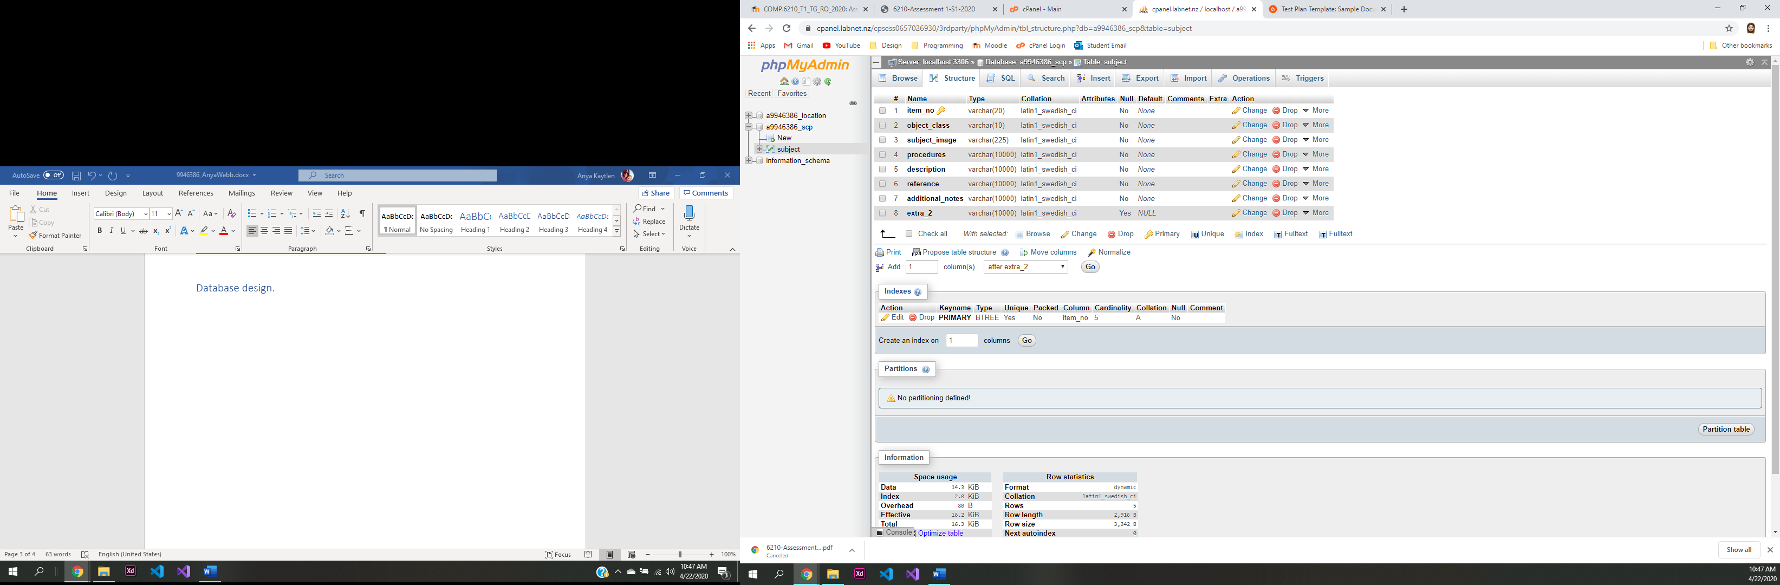

# Testing.

### Browsers:

|  |  |  |  |
| --- | --- | --- | --- |
| **Browser** | **Displayed correctly** | **Responsive** | **Pass/Fail** |
| Google Chrome | Yes | Yes | Pass |
| Microsoft Edge | Yes | Yes | Pass |
| Safari | Yes | Yes | Pass |

### Mobile Responsive:

iPhone 8 Plus: Pass

|  |  |
| --- | --- |
| Homepage: | Navigation: |
|  |  |

|  |  |
| --- | --- |
| Dropdown menu: | Subject pages: |
|  |  |

Enter new subject:

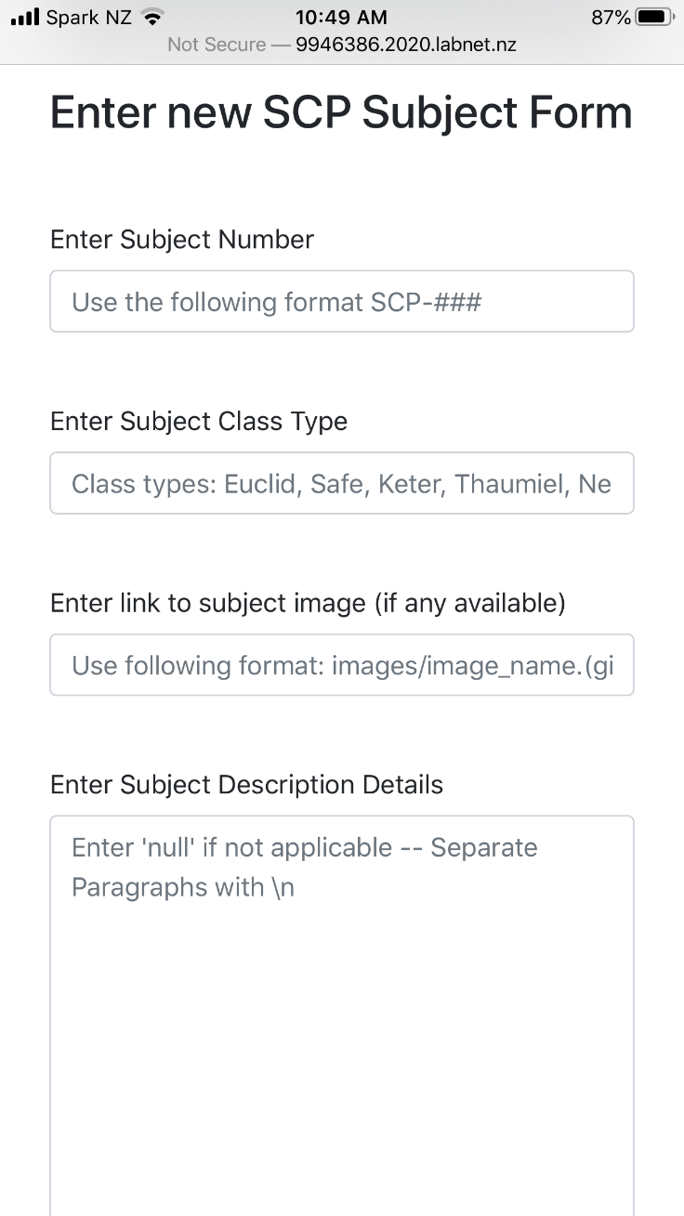

### Browser Testing:

|  |  |  |  |  |  |  |
| --- | --- | --- | --- | --- | --- | --- |
| **Num.** | **Action** | **Inputs** | **Expected Output** | **Actual Output** | **Browser** | **Result** |
| 1. | Load Homepage | Null | Loads correctly | Loaded correctly | Chrome | Pass |
| 2. | Open dropdown menu | Null | Subject files dropdown opens correctly | Opened correctly | Chrome | Pass |
| 3. | Open subject file | Null | Page opens and shows all data for the subject selected. | Page opened correctly | Chrome | Pass |
| 4. | Enter new subject table shows correctly | Null | Page opens showing all parts of the table | Page opened correctly | Chrome | Pass |
| 5. | New subject details can be entered and saved. | Sample data:  A, B, blank, C, D, E, F | All text blocks can be used and the data will be saved to database when submit button pushed | Text blocks worked and data was saved to database | Chrome | Pass–--- |
| 6. | Data entered in Subject A shows in the navigation | Null | Subject A shows in dropdown navigation | Subject showed correctly | Chrome | Pass |
| 7. | Subject A data displays correctly | Null | Data entered for Subject A shows correctly on the page | All data displayed correctly | Chrome | Pass |
| 8. | Subject A has been added to the database | Null | Subject A will show in PHPMyAdmin correctly in the database | Subject A has been entered into the database | Chrome | Pass |

### Photos:

